DEPARTMENT OF SURVEYING AND GEOINFORMATICS
LECTURE MATERIAL
DIGITAL MAPPING (GIT 410)

Digital mapping

(Also called digital cartography) is the process by which a collection of data is compiled and formatted into a virtual image. The primary function of this technology is to produce maps that give accurate representations of a particular area, detailing major road arteries and other points of interest.

What is cartography?

Is the “art, science and technology of making maps together with their study as scientific documents and works of art”. This includes map, plans charts and section, three dimensional model and globes representing the earth or any celestial body at any scale.

Digital cartography is therefore refers to the automation of cartographic processes including symbolization, map generalization, display and map printing.
What is a map?
A map is a symbolized image of geographic reality representing selected features or characteristics resulting from the creative efforts of cartographers and designed for use when spatial relationships are of special relevance. (ICA, 1995)

Digital Verses Analogue (Map) Data Base

Problems: - The use of analogue as a database is associated with a number of problems, thus;-
- Original data had to be greatly reduced in volumes or classified in order to make them understandable and represent able
- The map had to be drawn extremely accurately and its presentation of complex themes had to be very clear
- The sheer volume of information meant that areas that are large with respect to the map scale could only be represented by a number of map sheets
- Once data had been put into a map it is not easy nor cheap to retrieve or to combine them with other spatial data
- The printed map is a static qualitative document

It is extremely difficult to attempt quantitative spatial analysis with the units specified on thematic map without resorting to collecting new information for the specific purpose in hand.

Why Introducing Computer in Mapping or Automation System
- To make existing maps more quickly since all required data are resident in database (digital)
- It is faster and hence reduces cost as fewer hands are required
- To make maps for specific map user needs
- To make maps for production possible at situation where skilled staff are unavailable
- To allow for experimentation with different graphical representation of the same
- To facilitate map making and update when data already in digital form
- To minimize the use of printed map as data store and thereby to minimize the effect of classification and generalization on the quality of data

Limitations
- The cost and associated technical problems of converting existing geographic record into an automated file
- The huge amount of technical as well as financial over head which is required to maintain automated file i.e. computer, skilled software maintenance etc
- High cost of initial acquisition of system
- Marginal cost benefit in certain application

There is always additional cost in train and retraining of personnel, updating and renewal of hardware, software and some cases complete change of facilities e.g. storage media

The Operations in Digital Cartography

There are three main operations;
- Data capture or data acquisition
- Data processing- transformed into different structures to serve different functions
- Data presentation

The major components of digital mapping/cartography
- Data acquisition; - digitizing, scanning, field survey etc.
- Data classification;- allocating feature codes
- Data structuring;- vector, raster and topology
- Data restructuring;- raster to vector conversion
- Data editing;- correction
- Data transformation;- map projections
- Data selection;- feature overlay
- Data generalization;- small scale compilation
- Data enhancement;- graphic display, symbolization
- Data analysis;- calculating areas, distances, bearing etc.

The Digital Mapping Process

- Capture or access data
- Convert and transform projections, scales, coordinates, data structures
- Compose and design
- Select representation method
- Select symbols and text
- Apply design loop
- Publish or distribute

Input/output Devices
Some commonly used Input/output devices are listed in table below.
Input Devices | Output Devices
Keyboard  Mouse  Joystick  Scanner  Light Pen  Touch Screen | Monitor  LCD  Printer  Plotter

Input Devices
(a) Keyboard
It is a text base input device that allows the user to input alphabets, numbers and other characters. It consists of a set of keys mounted on a board.

Figure 1: The Keyboard

Alphanumeric Keypad
It consists of keys for English alphabets, 0 to 9 numbers, and special characters like + -
− / * ( ) etc.

Function Keys
There are twelve function keys labeled F1, F2, F3… F12. The functions assigned to these keys differ from one software package to another. These keys are also user programmable keys.

Special-function Keys
These keys have special functions assigned to them and can be used only for those specific purposes. Functions of some of the important keys are defined below.

Enter
It is similar to the ‘return’ key of the typewriter and is used to execute a command or program.

Spacebar
It is used to enter a space at the current cursor location.

Backspace
This key is used to move the cursor one position to the left and also delete the character in that position.

Delete
It is used to delete the character at the cursor position.
Insert
Insert key is used to toggle between insert and overwrite mode during data entry.

Shift
This key is used to type capital letters when pressed along with an alphabet key, Also, used to type the special characters located on the upper-side of a key that has two characters defined on the same key.

Caps Lock
Cap Lock is used to toggle between the capital lock features. When ‘on’, it locks the alphanumeric keypad for capital letters input only.
Tab
Tab is used to move the cursor to the next tab position defined in the document. Also, it is used to insert indentation into a document.

Ctrl
Control key is used in conjunction with other keys to provide additional functionality on the keyboard.

Alt
Also like the control key, Alt key is always used in combination with other keys to perform specific tasks.

Esc
This key is usually used to negate a command. Also used to cancel or abort executing programs.

Numeric Keypad
Numeric keypad is located on the right side of the keyboard and consists of keys having numbers (0 to 9) and mathematical operators (+ − * /) defined on them. This keypad is provided to support quick entry for numeric data.

Cursor Movement Keys
These are arrow keys and are used to move the cursor in the direction indicated by the arrow (up, down, left, right).

(b) Mouse

The mouse is a small device used to point to a particular place on the screen and select in order to perform one or more actions. It can be used to select menu commands, size windows, start programs etc.
The most conventional kind of mouse has two buttons on top: the left one being usedmost frequently.

Mouse Actions

Left Click: Used to select an item.
Double Click: Used to start a program or open a file.
Right Click: Usually used to display a set of commands.
Drag and Drop: It allows you to select and move an item from one location toanother. To achieve this place the cursor over an item on the screen, click the leftmouse button and while holding the button down move the cursor to where you wantto place the item, and then release it.

Fig.2:The Mouse

(c) Joystick

The joystick is a vertical stick which moves the graphic cursor in a direction the stickis moved. It typically has a button on top that is used to select the option pointed bythe cursor. Joystick is used as an input device primarily used with video games,training simulators and controlling robots

Figure 3: The Joystick

(d)Scanner

Scanner is an input device used for direct data entry from the source document into the computer system. It converts the document image into digital form so that it can be fed into the computer. Capturing information like this reduces the possibility of errors typically experienced during large data entry.

Figure 4: The Scanner

Hand-held scanners are commonly seen in big stores to scan codes and price information for each of the items. They are also termed the bar code readers.

(e) Bar codes

A bar code is a set of lines of different thicknesses that represent a number. Bar Code
Readers are used to input data from bar codes. Most products in shops have bar codes on them. Bar code readers work by shining a beam of light on the lines that make up the bar code and detecting the amount of light that is reflected back

Figure 5: The Bar Code Reader

(f) Light Pen

It is a pen shaped device used to select objects on a display screen. It is quite like the mouse (in its functionality) but uses a light pen to move the pointer and select any object on the screen by pointing to the object.
Users of Computer Aided Design (CAD) applications commonly use the light pens to directly draw on screen.

(g) Touch Screen

It allows the user to operate/make selections by simply touching the display screen.
Common examples of touch screen include information kiosks, and bank ATMs.

(h)Digital camera

A digital camera can store many more pictures than an ordinary camera. Pictures taken using a digital camera are stored inside its memory and can be transferred to a computer by connecting the camera to it. A digital camera takes pictures by converting the light passing through the lens at the front into a digital image.

Figure 6: The Digital camera
(i) The Speech Input Device
The “Microphones - Speech Recognition” is a speech Input device. To operate it we require using a microphone to talk to the computer. Also we need to add a sound card to the computer. The Sound card digitizes audio input into 0/1s .A speech recognition program can process the input and convert it into machine-recognized commands or input.

Figure 7: The Microphone

(j) Automatic Digitizer

The devices convert existing (Analogue) maps and drawings into digital raster format automatically.

Output Devices
(a) Monitor
Monitor is an output device that resembles the television screen and uses a Cathode
Ray Tube (CRT) to display information. The monitor is associated with a keyboard for manual input of characters and displays the information as it is keyed in. It also displays the program or application output. Like the television, monitors are also available in different sizes.

(b) Liquid Crystal Display (LCD)
LCD was introduced in the 1970s and is now applied to display terminals also. Its advantages like low energy consumption, smaller and lighter have paved its way for usage in portable computers (laptops).

Figure 8: The LCD

(c) Printer

Printers are used to produce paper (commonly known as hardcopy) output. Based on the technology used, they can be classified as Impact or Non-impact printers.
Impact printers use the typewriting printing mechanism wherein a hammer strikes the paper through a ribbon in order to produce output. Dot-matrix and Character printers fall under this category.

Non-impact printers do not touch the paper while printing. They use chemical, heat or electrical signals to etch the symbols on paper. Inkjet, DeskJet, Laser, Thermal printers fall under this category of printers.
When we talk about printers we refer to two basic qualities associated with printers: resolution, and speed. Print resolution is measured in terms of number of dots per inch (dpi). Print speed is measured in terms of number of characters printed in a unit of time and is represented as characters-per-second (cps), lines-per-minute (lpm), or pages-per-minute (ppm).

Figure 9: The Printer

(d) Plotter
Plotters are used to print graphical output on paper. It interprets computer commands and makes line drawings on paper using multicolored automated pens. It is capable of producing graphs, drawings, charts, maps etc.
Computer Aided Engineering (CAE) applications like CAD (Computer Aided
Design) and CAM (Computer Aided Manufacturing) are typical usage areas for plotters.

Figure 10: The Plotter
(e) Audio Output: Sound Cards and Speakers:
The Audio output is the ability of the computer to output sound. Two components are needed: Sound card – Plays contents of digitized recordings, Speakers – Attached to sound card.

Digital Mapping Software

What is digital mapping software?
Digital mapping is the basis of Geographic Information Systems (GIS) software such as Maptitude, allowing geospatial analysis and the visualization of location-based data. There are several GIS software packages in use. Typical GIS software often contains tools in form of algorithms (programs, rules or commands) for performing certain tasks such as data input, storage, retrieval and analysis, query, output and updating. There are generalized as well as specialized GIS software packages. Below is the list of some Digital Cartography Software;-
- Raster point
- QGIS formerly Quantum GIS
- Easy map
- maptitude
- 3D Map Application
- Corel Draw
- Map Viewer
- Automation Map Generation
- Adobe Illustration
- Mapublisher
- Aidus free Hand
Data
The component is very crucial to the successful implementation of any GIS project. Data simply refers to the facts or information about some geographic feature. In other way, it is a measure of quantities which does not give any information unless it is processed.
Vector Data
Maps can be seen as a set of lines, points, and polygons and stored in cartographic database. Such vector data can be produced automatically from scanned maps by extracting the vector from the raster or directly from manual digitizing.
Ortho-photo
This is an aerial photograph that has been geometrically corrected (ortho-rectified). Such that the scale of photograph is uniform and utilized in the same manner as a map
Model
This is a class that defines the properties and behaviors of data that you present to the user
Data Models for GIS
In order to visualize natural phenomena, one must first determine how to bestrepresent geographic space. Data models are a set of rules and/or constructs usedto describe and represent aspects of the real world in a computer. Two primary datamodels are available to complete this task: raster data models and vector datamodels.
Raster Data Models
The raster data model is widely used in applications ranging far beyond geographic information systems (GISs). Most likely, you are already very familiar with this data model if you have any experience with digital photographs. The ubiquitous JPEG, BMP, and TIFF file formats (among others) are based on the raster data model. Take a moment to view your favorite digital image. If you zoom deeply into the image, you will notice that it is composed of an array of tiny square pixels (or picture elements). Each of these uniquely colored pixels, when viewed as a whole, combines to form a coherent image.

The raster data model consists of rows and columns of equally sized pixels interconnected to form a planar surface. These pixels are used as building blocks for creating points, lines, areas, networks, and surfaces.
Although pixels may be triangles, hexagons, or even octagons, square pixels represent the simplest geometric form with which to work.
These squares are typically reformed into rectangles of various dimensions if the data model is transformed from one projection to another (e.g., from State Plane coordinates to UTM [Universal Transverse Mercator] coordinates).

Vector Data Models
In contrast to the raster data model is the vector data model. In this model, space is not quantized into discrete grid cells like the raster model. Vector data models use points and their associated X, Y coordinate pairs to represent the vertices of spatial features, much as if they were being drawn on a map by hand
The data attributes of these features are then stored in a separate database management system. The spatial information and the attribute information for these models are linked via a simple identification number that is given to each feature in a map.
Three fundamental vector types exist in geographic information systems (GISs): points, lines, and polygons.
Points are zero-dimensional objects that contain only a single coordinate pair. Points are typically used to model singular, discrete features such as buildings, wells, power poles, sample locations, and so forth. Points have only the property of location.
Other types of point features include the node and the vertex. Specifically, a point is a stand-alone feature, while a node is a topological junction representing a common X, Y coordinate pair between intersecting lines and/or polygons. Vertices are defined as each bend along a line or polygon feature that is not the intersection of lines or polygons. Points can be spatially linked to form more complex features.

Lines are one dimensional feature composed of multiple, explicitly connected points. Lines are used to represent linear features such as roads, streams, faults, boundaries, and so forth. Lines have the property of length. Lines that directly connect two nodes are sometimes referred to as chains, edges, segments, or arcs.
Polygons are two-dimensional features created by multiple lines that loop back to create a “closed” feature. In the case of polygons, the first coordinate pair (point) on the first line segment is the same as the last coordinate pair on the last line segment. Polygons are used to represent features such as city boundaries, geologic formations, lakes, soil associations, vegetation communities, and so forth. Polygons have the properties of area and perimeter. Polygons are also called areas.

Vector and Raster Data Models

- Spatial data can represent real-world features that have discrete boundaries (such as roads, buildings, lakes, rivers, administrative boundaries) as well as real-world phenomena/features that have non-discrete boundaries (such as precipitation and nutrient levels, terrain).
- In general, the vector data model is used to represent the former and the raster data model to represent the latter.
- However, the lines od separation are sometimes crossed.
- As well, a typical GIS process involves moving back-and-forth between the two models.

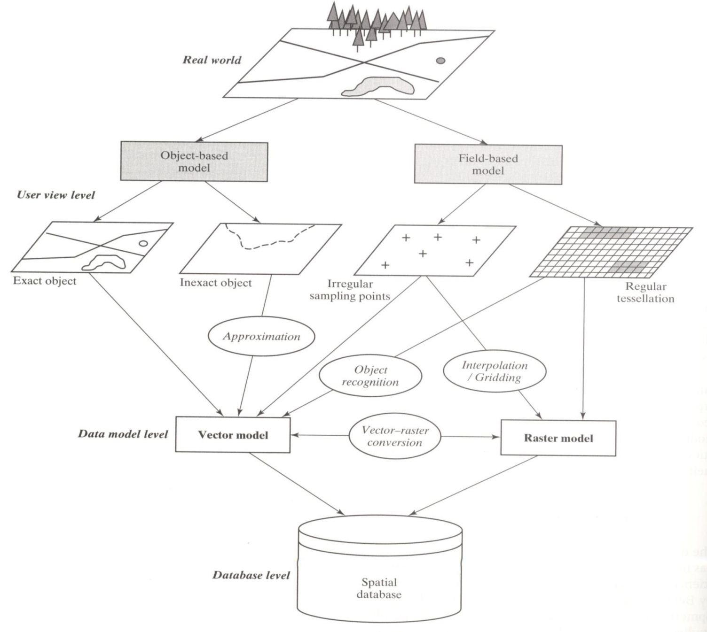

Raster vs. Vector Data Model Representations of the Real World

•Elevation, as a continuous land (field) characteristic, is usually stored in a vector file for easier data management, but is more suitable to be represented by a raster data model.

•Although discrete objects such as buildings, ski lifts, roads, are usually not represented by a raster data model, they are handy for illustrating a direct comparison of representation between a raster and a vector data model.

Map Updating (Editing)
Before using any data in GIS environment, the data should be geo-referenced. Geo-referencing (also known as geo-rectification, geo-locating, geo-coding or registering) is the process of assigning spatial location identity to pieces of information. In other words, it is the process of giving a cartographic material such as a digital satellite imagery, aerial photograph, map, or statistical data a real world coordinate system and map projection. Kasianchuk and Taggart (2004) simply put it, “Geo-referencing is the process of establishing a relation between the data displayed in your GIS software and its real-world location.” So, when we embark on geo-referencing we are simply trying to use households or farmlands or some other features likely to be affected by the spillage.
Map updating is to add more features of interest in order to improve and update map.
Step by step account on how to edit map is thus;
- Obtain satellite image of a place say, Adamawa state
- Use GPS to establish geo-reference control for geo-data (the satellite images need control in order to make any features reference)
- Identify various layers that will be used for the production of the Digital mapping, e.g. Settlement, roads, streams/Rivers, and Local Government areas boundary
- Obtain map (boundary) of Adamawa State showing all the existing boundary
- Scan the image
- Digitize the image based on selected layers (Shape file)
- Various spatial data could then be combined together as layers in order to get the required map of the place of interest

Data Storage

- Map stored as image;- This is a simple cartographic view of map. The map surface is divided into regular cells (pixels) and for each of the color and intensity is recorded in a cartographic database. Such data can easily be collected by scanning existing maps and the maps later reproduced from the data.

Digital Terrain Model
The digital terrain model (DTM) is simply a statistical representation of the continuous surface of the ground by a large number of selected points with known X, Y,Z coordinates in an arbitrary coordinate field.
Compared to traditional analog representation, a DTM has the following specific features:
- A variety of representation forms: In digital form, various forms of representations can be easily produced, such as topographic maps, vertical and cross sections, and 3-D animation.
- No accuracy loss of data over time: As time goes by, paper maps may be deformed, but the DTM can keep its precision owing to the use of digital medium.
- Greater feasibility of automation and real-time processing: In digital form, data integration and updating are more flexible than in analog form.
- Easier multi-scale representation: DTM can be arranged in different resolutions, corresponding to representations at different scales.

Digital Elevation Models and Digital Terrain Models

In a sense, the DTM was defined as a digital (numerical) representation of the terrain.These include digital elevation models (DEMs), digital height models (DHMs), digital ground models (DGMs), as well as digital terrain elevation models (DTEMs). These terms originated from different countries. DEM was widely used in America; DHMcame from Germany; DGMwas used in the United Kingdom; and DTEM was introduced and used by USGS andDMA(Defense Mapping Agency).
In practice, these terms (DTM, DEM, DHM, and DTEM) are often assumed to be synonymous and indeed this is often the case. But sometimes they actually refer to different products. That is, there may be slight differences between these terms.
A comparative analysis of these differences is as follows:
- Ground: “the solid surface of the earth”; “a solid base or foundation”; “a surface of the earth”; “bottom of the sea”; etc.
- Height: “measurement from base to top”; “elevation above the ground or recognized level, especially that of the sea”; “distance upwards”; etc.
- Elevation: “height above a given level, especially that of sea”; “height above the horizon”; etc.
- Terrain: “tract of country considered with regarded to its natural features, etc.”; “an extent of ground, region, territory”; etc.

From these definitions, some of the differences between DGM, DHM, DEM, and DTM begin to manifest themselves. So, a DGM more or less has the meaning of “a digital model of a solid surface.” In contrast to the use of ground, the terms height and elevation emphasize the “measurement from a datum to the top” of an object. They do not necessarily refer to the altitude of the terrain surface, but in practice, this is the aspect that is emphasized in the use of these terms. The meaning
“Terrain” is more complex and embracing. It may contain the concept of “height” (or “elevation”), but also attempts to include other geographical elements and natural features. Therefore, the term DTM tends to have a wider meaning than DHM orDEM and will attempt to incorporate specific terrain features such as rivers, ridge lines, break lines, etc. into the model.
Indeed, the term terrain means different things to specialists in different areas and so does the term DTM. Surveyors study DTM from the viewpoint of terrain representation and are especially interested in the topography of the terrain and objects in the terrain. The idealDTMin their mind could be the newgeneration of topographic maps, of course, in digital form.
Specialists in other geosciences combine the non-topographic information with topographic information to construct the DTM according to their own specific needs.
Generally, a DTM could contain the following four groups of (topographic and non-topographic) information as follows:
- Landforms, such as elevation, slope, slope form, and the other more complicatedgeo-morphological features that are used to depict the relief of the terrain.
- Terrain features, such as hydrographic features (i.e., rivers, lakes, coast lines),transportation networks (i.e., roads, railways, paths), settlements, boundaries, etc.
- Natural resources and environments, such as soil, vegetation, geology, climate, etc.
- Socioeconomic data, such as the population distribution in an area, industry andagriculture and capital income, etc.

Acquisition of Data for DTM
Acquisition of topographic information is of prime importance in digital terrain modeling. Three main methods are used for generation of topographic information, namely;-
- Field or Ground surveying method
- Photogrammetric method
- Graphic Digitizing method

Sampling for DTM
Several methods exist for obtaining or sampling terrain elevation information. The choice of sampling approach depends on the available hardware/software configuration, and a decision or the balance between integrity of information, accuracy, time and storage space.

Sampling types

- Regular pattern sampling;- This involves breaking the area involve into regular geometric patterns or grid such as square, rectangles, triangles or another systematic pattern. The essence is to acquire terrain data necessary to define a satisfactory model. Height measurements are made at the node points or data points. A general advantage of this method lies in the fact that it is mostly easily implemented in a computer controlled system such as analytical plotters.
- Progressive sampling;- In the grid-based techniques, the size of the grid determines the density of data to be acquired. Small size grid means more resolution and larger volume of Data to be handled. In progressive sampling method, a widely spread (Low resolution grid) which gives a good general coverage of the entire area to be modeled is used, then a progressive increase in the density of sampling takes place on the basis of an analysis of terrain relief and slope. For example, the basic grid can be densified by reducing its size by half in certain limited areas depending upon their ruggedness characteristic
- Selective sampling;- In the grid based sampling, height measurements are made in accordance with a predetermined symmetrical pattern irrespective of the terrain irregularities. In selective sampling method, data are acquired in accordance with local roughness or ruggedness of the terrain surface. That is, height are measured selectively at distinct or critical location such as valley, peaks, sudden breaks on topography, ridges, etc in other to best approximate the relief. This method need a lot of human input because the surveyor or photogrammetric has to identify critical location by inspecting and interpreting terrain features.
- Composite sampling;- This method combines the elements of grid measurement method and those of selective sampling techniques. In other words, the basic grid measurements densified by measurements made at critical points is the terrain. The method is particularly suitable for an operator controlled type of stereo plotting instrument.

